Firebase

It is backend server solution that gives us the abstraction layer around backend,

Firebase is a mobile and web platform which is built on top of Google cloud platform.

It means that it can be used along with any Google cloud service.

don't need to worry about creating our own API database maintenance file, hosting.

So in our code, instead of sending a request to an API to retrieve data, we would just use a library that has functions already predefined for us, like get this document by ID and this function will 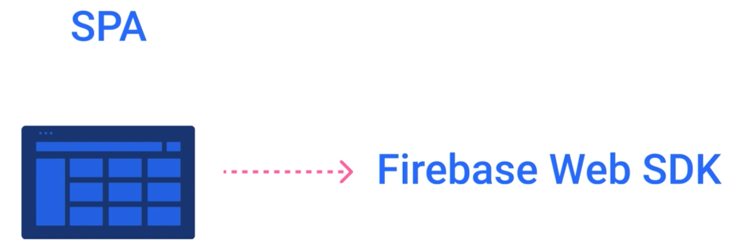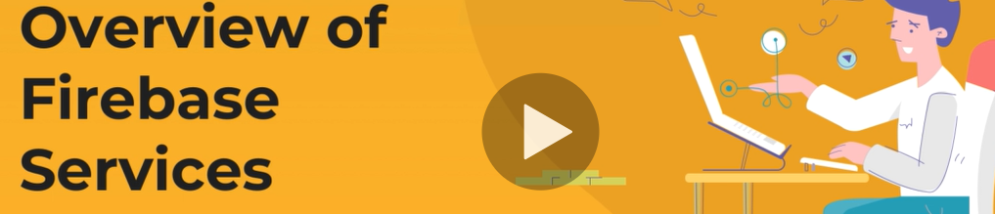interact with the database.

It has real time support and fast queries and it is also well documented, which is really important

We can manage multiple apps.

There can be multiple web apps that will share the same database.

Or if we had Android, AOS and Web applications, we could manage all of them from single dashboard

We are able to log in and authenticate users across our applications. There are lots of different sign and methods available for us. And the thing is that all of them are configurable with just a few clicks.

t has a built in email system that handles all email verifications and resets.

We need to only customize the template of the e-mail.

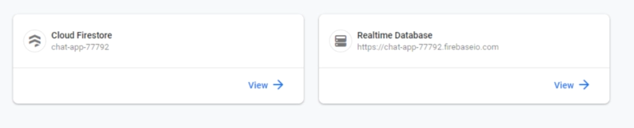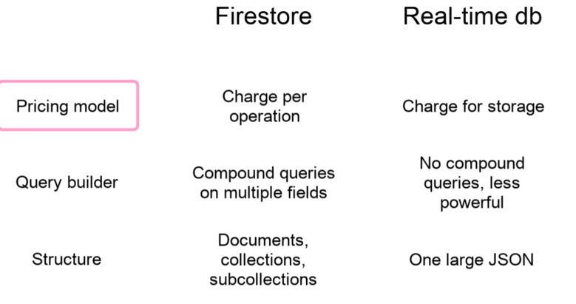

We will use real time database because we will have a lot of read and write operations and we do not require complex queries.

If it wasn't a chat application, I would have piqued fire store as it has more sophisticated queries and database structure.

**Firebase hosting.**

to deploy website. It only supports static files. So if we have a server side rendering application, this hosting will not work.

**Cloud functions in our application.**

We are also able to write custom backend in the form of server less cloud functions that can be called from inside the code. We are going to deploy only one that will send notifications to users.

**Machine Learning Kit.**

Amazing tool that provides machine learning utilities such as image recognition and the others. But unfortunately it is only available for AOS and Android apps at the bottom.

**Firebase Analytics**, which is basically Google analytics but wrapped as a firebase service

We will use **only firebase cloud messaging** that will allow us to send **real time notifications to users** if browser has support for it.

**Firebase security**

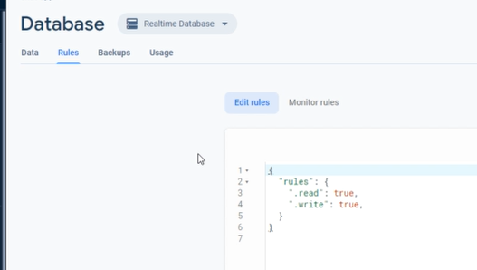

**security rules**.

These rules define how data can be accessed and by who.

It means that the level of security depends on how good security rules are written.

It is a good practice to lock down the database by default and then adjust rules.

As we write code, **security rules apply only to client side.**

If we write custom backend with cloud functions, these rules will not apply when application grows.

Some people find it hard to write security rules.

For this reason, they use cloud functions and perform a server side validation themselves.

The same applies to cloud storage.



**Spark plan is free**